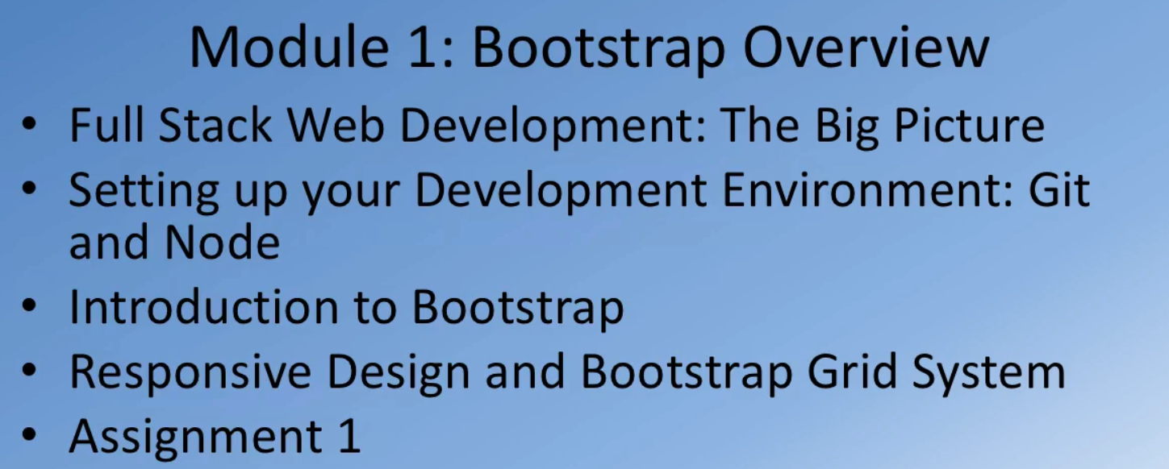

# Full Stack Web Development: The Big Picture

